Weblogic Server 14.1.1 enterprise and Oracle JDK 11 deployment and domain creation
-WebLogic Server 14.1.1 Installation and middleware home validation
Stage JDK 11 and WebLogic Server 14.1.1 to install on app server
Install jdk 11.0.31 on /u01/app/java
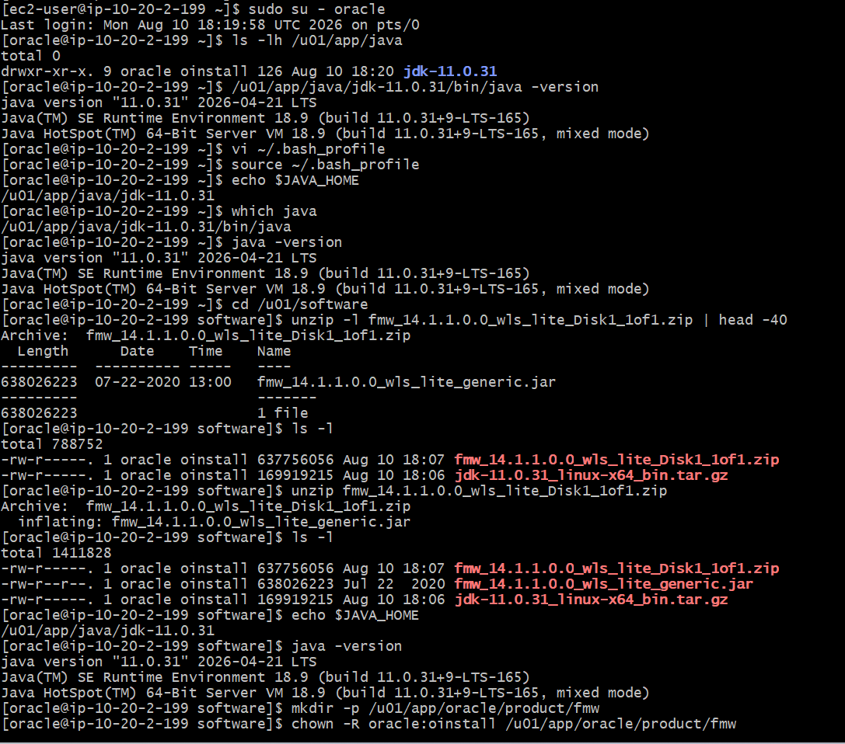
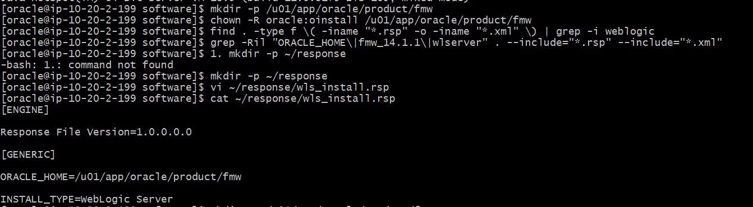
Create the middleware directories
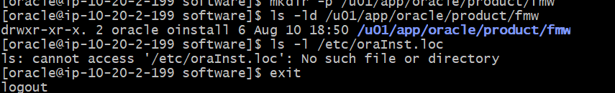

Install weblogic server 14.1.1using custom response file
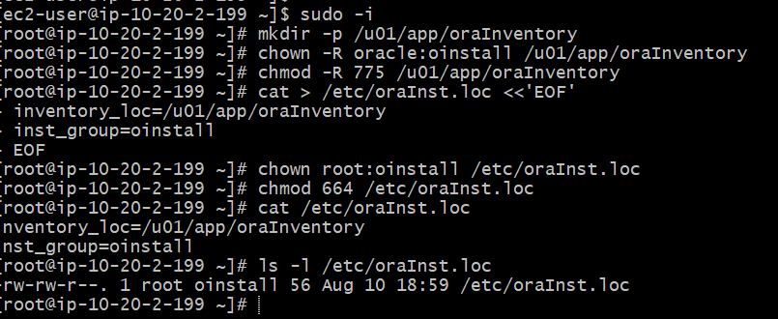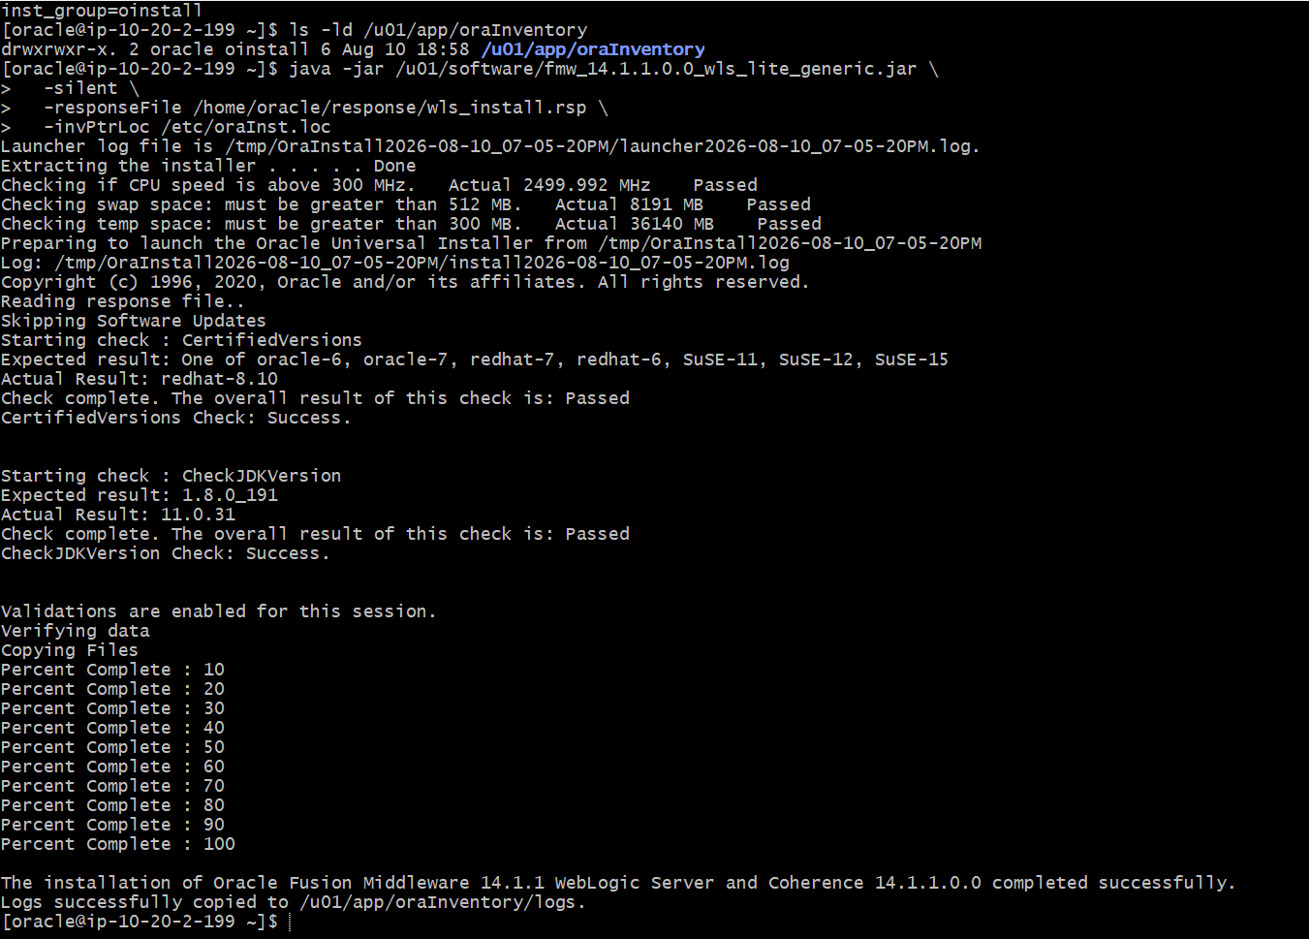

WebLogic Server 14.1.1 Installation and middleware home validation
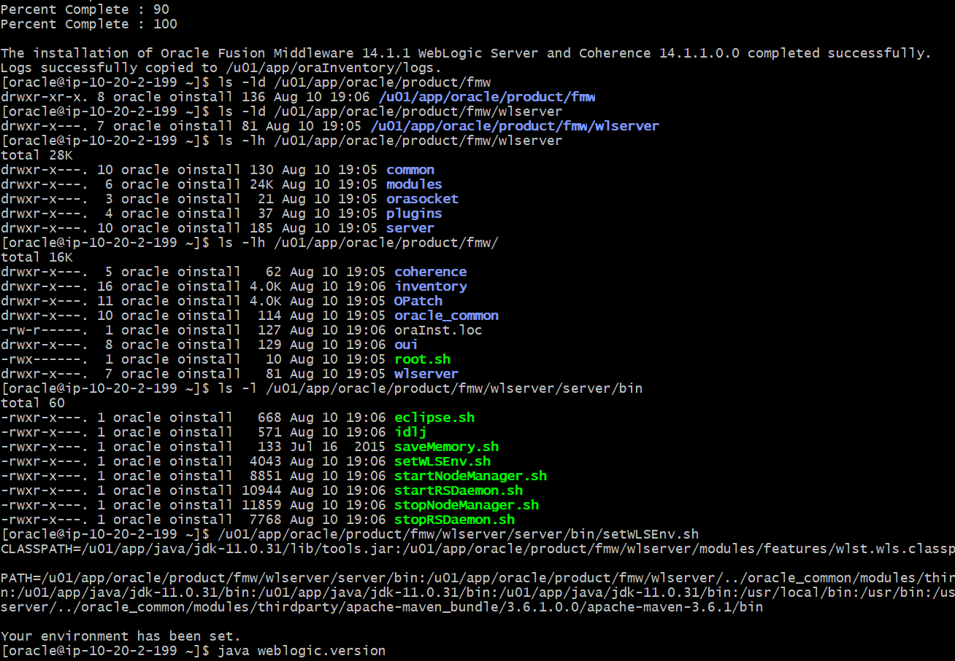
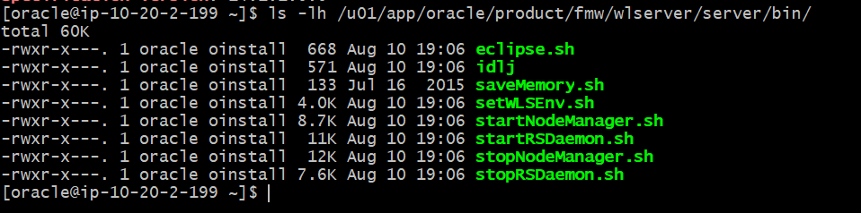

Automated tinacloud Domain creation with WLST
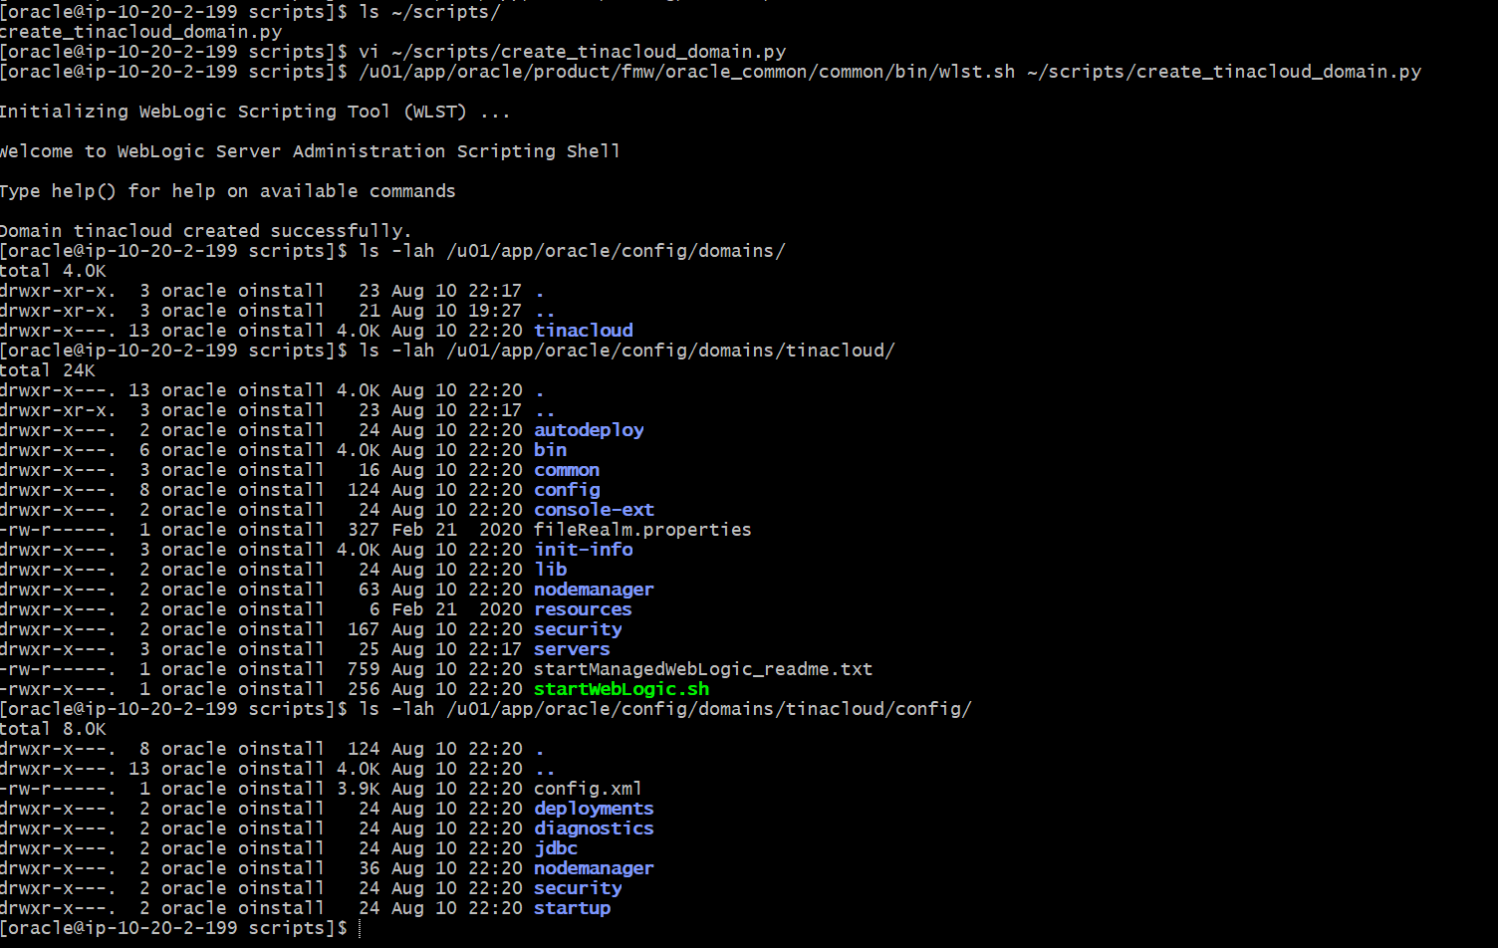
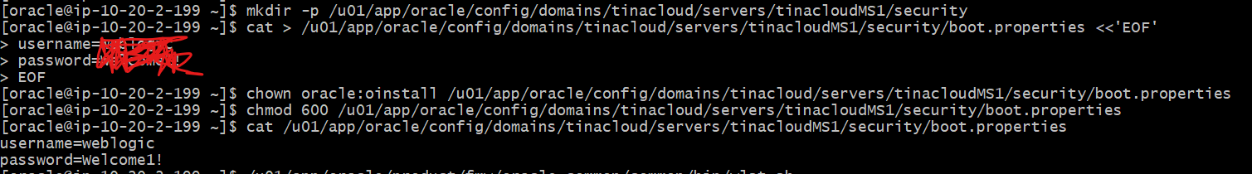

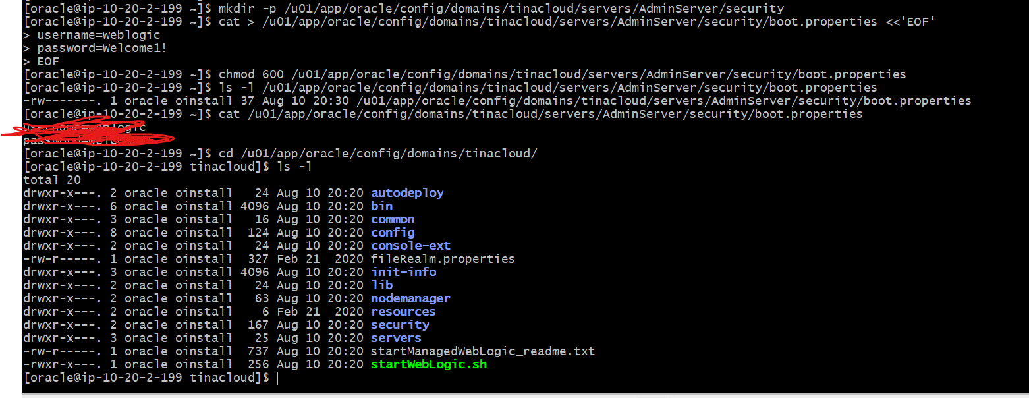
Start node manager:
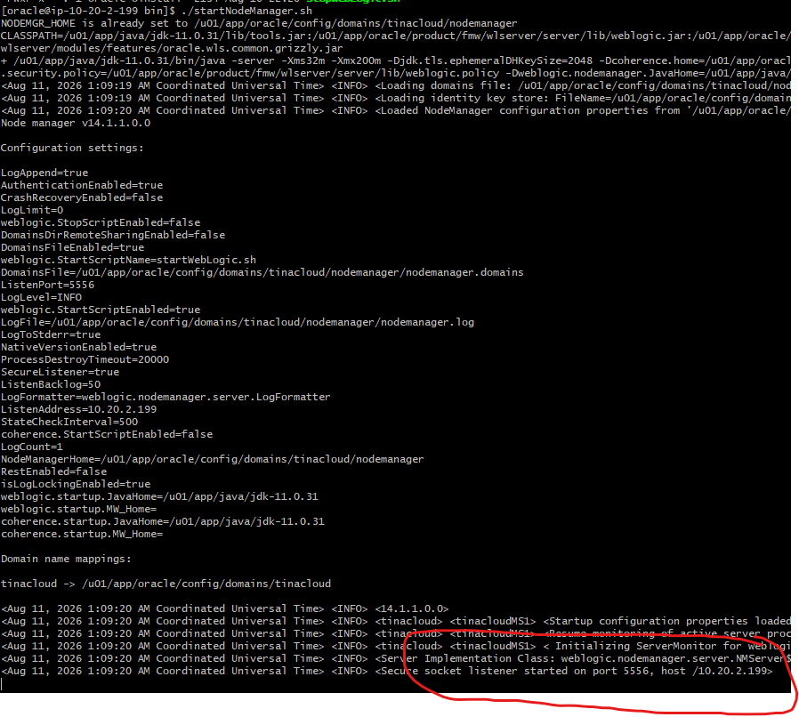
Start admin server:
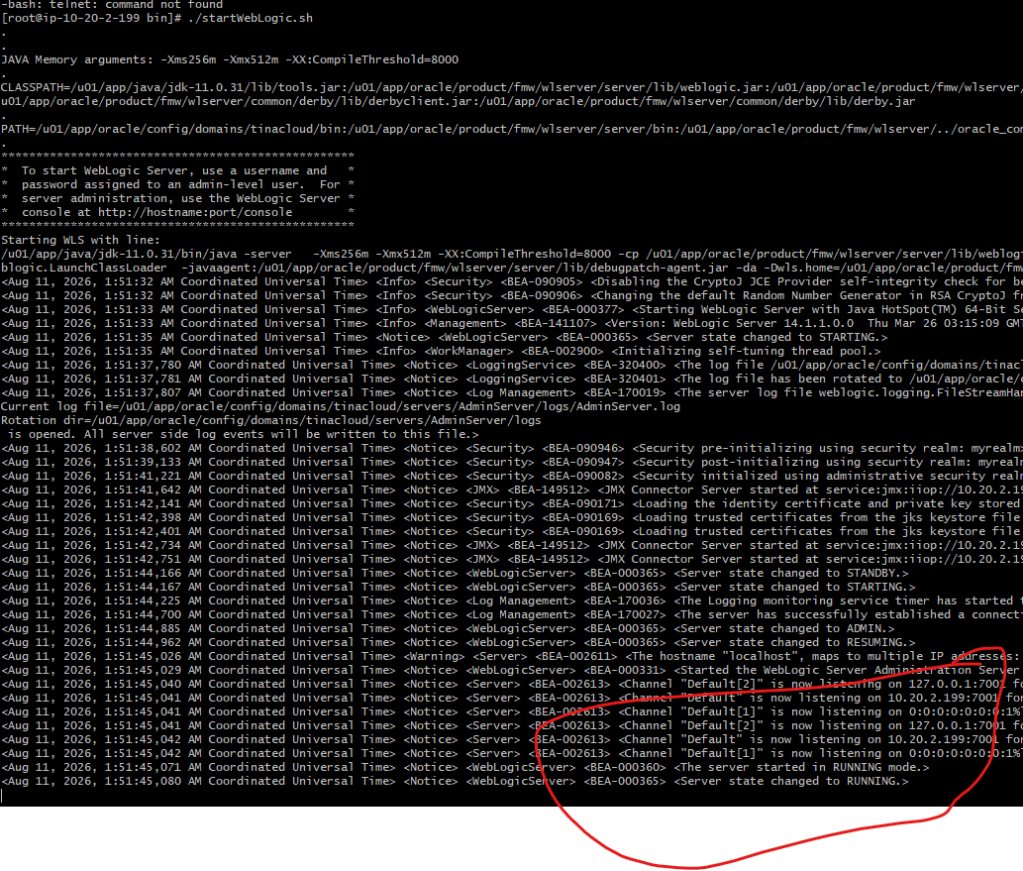

Connect to WLST and use node manager to start managed server
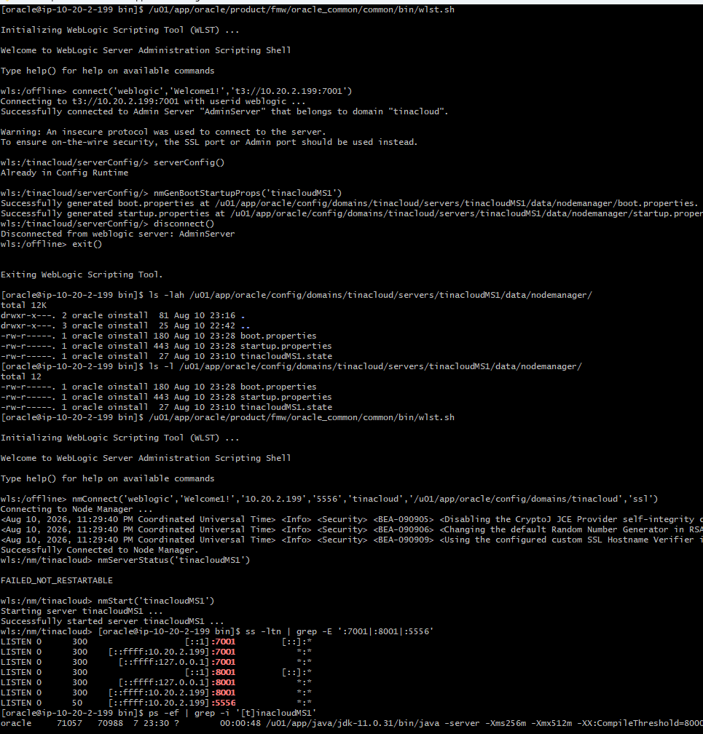

Managed successfully started using node manager
